CS-330

Module Two Milestone

Laura McAroy

March 11th, 2023

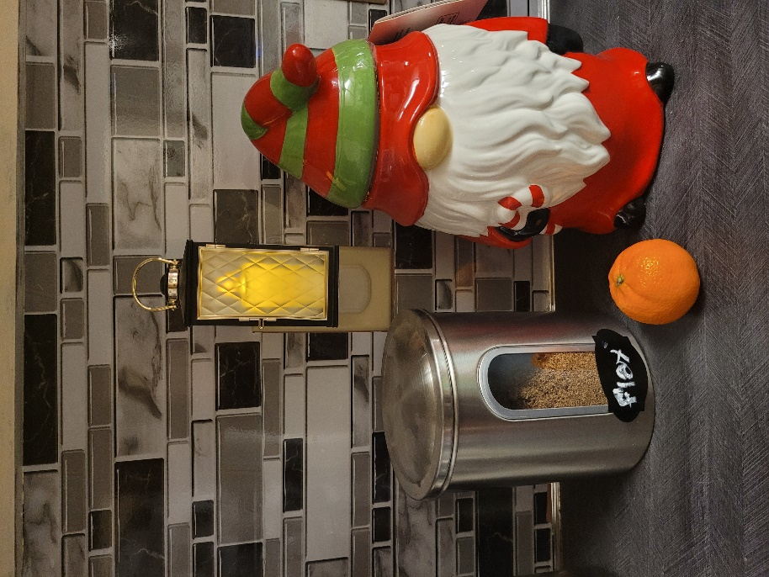

For this project, I will be recreating these objects I found in my kitchen. I have a canister, an orange, a nightlight, and my Christmas cookie jar that is still sitting out even though it is now March. I chose these four objects because they are almost perfect renditions of the 3D shapes I will be using, so in theory, they should be fairly simple to recreate.

To recreate the scene, I will use a plane to represent the countertop that the majority of the objects are sitting on. The canister will only require me to create a cylinder, and the orange is just a basic sphere. An elongated cube will be used for the nightlight, and the cookie jar will be my complex object, for which I intend to use a cylinder for the base and a pyramid on top to represent the hat.